**Week 4**

**Shubham Garg**

**9919103057**

**F2**

**Q1**

#include<stdio.h>

#include<string.h>

int main()

{

FILE *fp;

fp=fopen("Q1.txt","w");

if(fp==NULL)

{

printf("file does not exit");

}

int n,i,j;

scanf("%d",&n);

char s[n][30];

fflush(stdin);

for(i=0;i<n;i++)

{

gets(s[i]);

fputs(s[i],fp);

fputs("\n",fp);

}

fclose(fp);

}

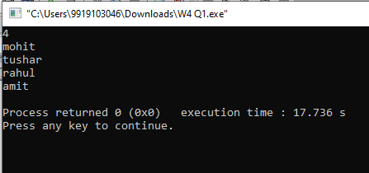

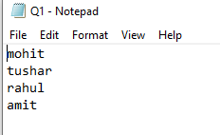

**Q1 Part b**

#include<stdio.h>

#include<string.h>

int main()

{

FILE *fs;

int n,i,j;

scanf("%d",&n);

char c[n][30],temp[30];

fs=fopen("Q1.txt","r+");

for(i=0;i<n;i++)

{

fgets(c[i],30,fs);

}

for(j=0;j<n;j++)

{

for(i=j+1;i<n;i++)

{

if(strcmp(c[j],c[i])>0)

{

strcpy(temp,c[j]);

strcpy(c[j],c[i]);

strcpy(c[i],temp);

}

}

}

for(i=0;i<n;i++)

{

printf("%s",c[i]);

}

FILE *fe;

fe=fopen("sort.txt","w");

for(i=0;i<n;i++)

{

fputs(c[i],fe);

fputs("\n",fe);

}

}

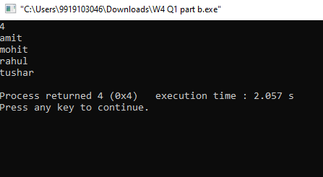

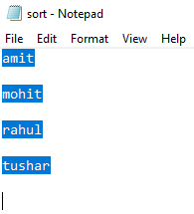

**Q2**

#include<stdio.h>

int main()

{

FILE *fp;

fp=fopen("yes.txt","w");

int n,i;

scanf("%d",&n);

int a[n];

for(i=0;i<n;i++)

{

scanf("%d",&a[i]);

fprintf(fp,"%d\n",a[i]);

}

fclose(fp);

}

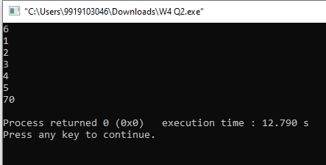



**Q2 Part b**

#include<stdio.h>

int main()

{

FILE *fp1;

int i,n=6;

fp1=fopen("yes.txt","a+");

int b[n],max=-1,min=100;

for(i=0;i<n;i++)

{

fscanf(fp1,"%d\n",&b[i]);

if(max<b[i])

max=b[i];

if(min>b[i])

min=b[i];

}

fprintf(fp1,"\nmax=%d\nmin=%d",max,min);

fclose(fp1);

}

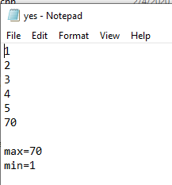

**Q3**

#include<stdio.h>

#include<string.h>

int main()

{

int c=0,c1=0,flag=0;

FILE *fp,*fp1;

char f1,f2,a,b,fa[30],fb[30];

scanf("%s",&fa);

scanf("%s",&fb);

fp=fopen(fa,"r");

fp1=fopen(fb,"r");

while(1)

{

f1=fgetc(fp);

if(f1==EOF)

break;

else

c++;

}

rewind(fp);

while(1)

{

f2=fgetc(fp1);

if(f2==EOF)

break;

else

c1++;

}

rewind(fp1);

printf("%d",c-c1);

if(c!=c1)

{

printf("files are not identical");

}

else

{

a=fgetc(fp);

b=fgetc(fp1);

while(a!=EOF && b!=EOF)

{

if(a==b)

{

flag++;

}

a=fgetc(fp);

b=fgetc(fp1);

}

if(flag==c1)

printf("Yes identical");

}

}

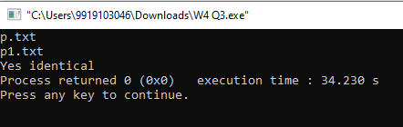

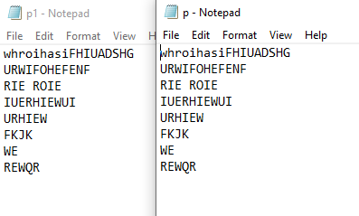

**Q4**

#include<stdio.h>

#include<string.h>

int main()

{

FILE *fp,*fs;

fp=fopen("p.txt","r");

fs=fopen("stud.txt","w");

char ch;

while(feof(fp)!=1)

{

ch=fgetc(fp);

fputc(ch,fs);

}

fclose(fp);

fclose(fs);

}

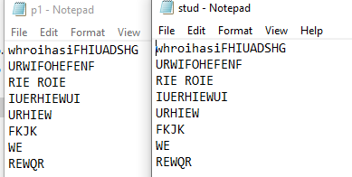

**Q5**

#include<stdio.h>

#include<string.h>

int main()

{

int flag=0;

FILE *fp,*fp1,*fpp;

char f1,f2,a[30],b[30],fa[30],fb[30];

//scanf("%s",&fa);

//scanf("%s",&fb);

int c=0,c1=0,c2=0,m=0;

fp=fopen("p.txt","r");

fp1=fopen("p1.txt","r");

fpp=fopen("w.txt","w");

while(1)

{

f1=fgetc(fp);

if(f1==EOF)

break;

else

c++;

}

rewind(fp);

while(1)

{

f2=fgetc(fp1);

if(f2==EOF)

break;

else

m++;

}

rewind(fp1);

while(c!=c1 || m!=c2)

{

if(flag%2==0)

{

fgets(a,9,fp);

fputs(a,fpp);

c1=c1+strlen(a);

} else

{

fgets(b,9,fp1);

fputs(b,fpp);

c2+=strlen(b);

}

flag++;

}

}

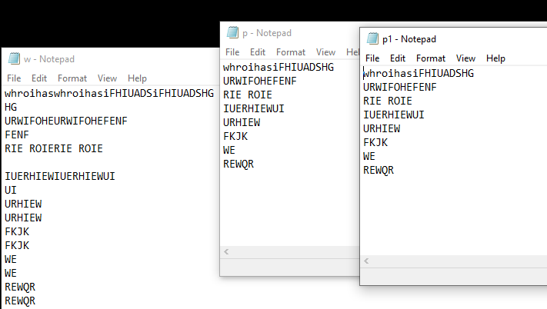

**Q6**

int n,i;

scanf("%d",&n);

struct cust x1[n],temp;

FILE *fp1;

fp1=fopen("student.txt","r");

int k=0,j;

for(i=0;i<n;i++)

{

fscanf(fp1,"%d %s %s",&x1[i].s_no,x1[i].branch,x1[i].name);

}

for(i=0;i<n;i++)

{

for(j=i+1;j<n;j++)

{

if(strcmp(x1[i].branch,x1[j].branch)>0)

{

temp=x1[j];

x1[j]=x1[i];

x1[i]=temp;

}

}

}

for(i=0;i<n;i++)

{

printf("%d\t",x1[i].s_no);

printf("%s\t",x1[i].name);

printf("%s\n",x1[i].branch);

}